**STEP 1: Create the React App**

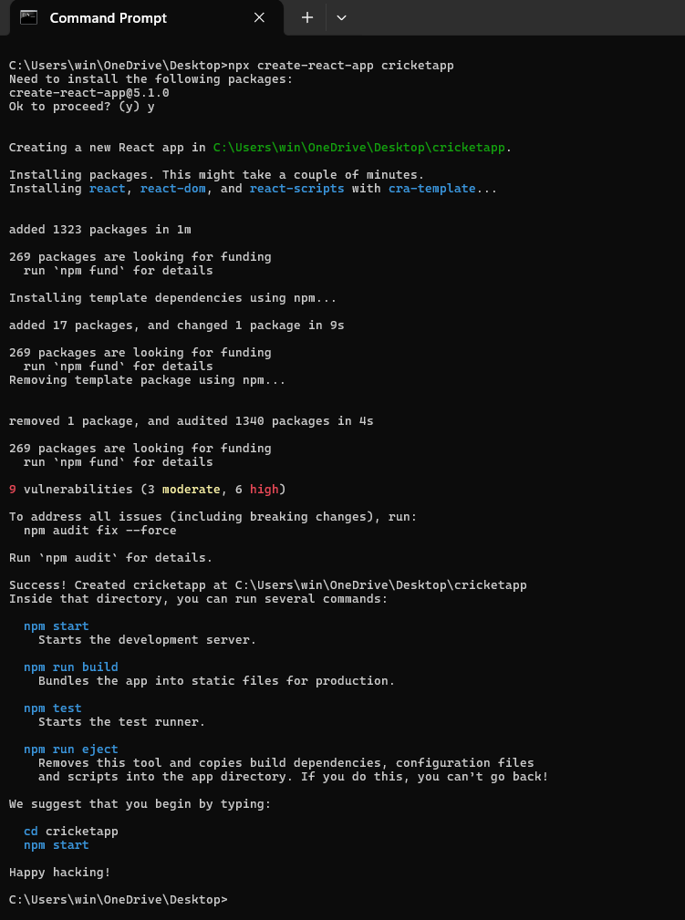

**STEP 2: Create Components**

Inside src/, create:

* ListofPlayers.js
* IndianPlayers.js

Also, modify App.js to control which component is shown using a flag.

**STEP 3: Create ListofPlayers Component**

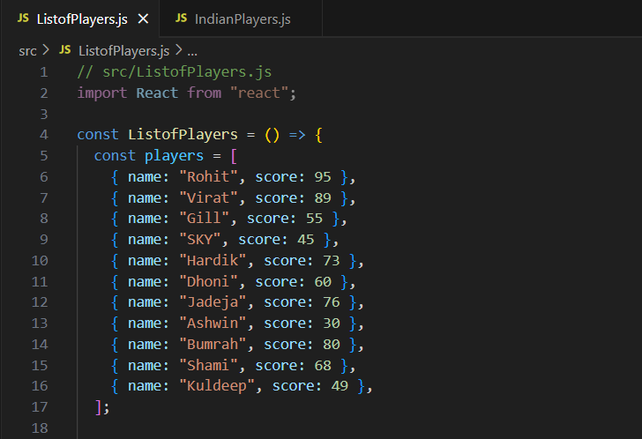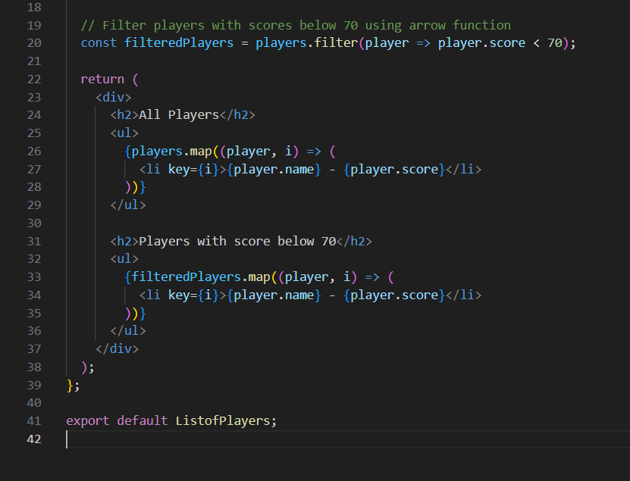

**STEP 4: Create IndianPlayers Component**

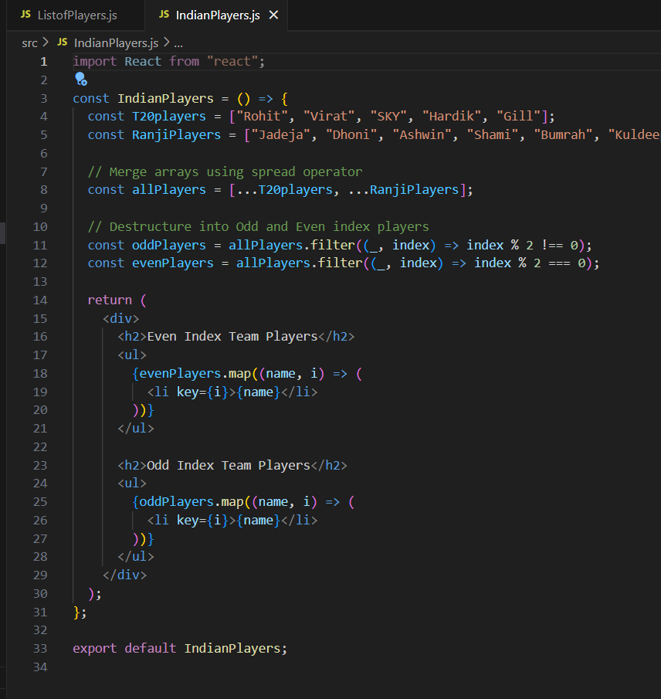

**STEP 6: Modify App.js to toggle between components**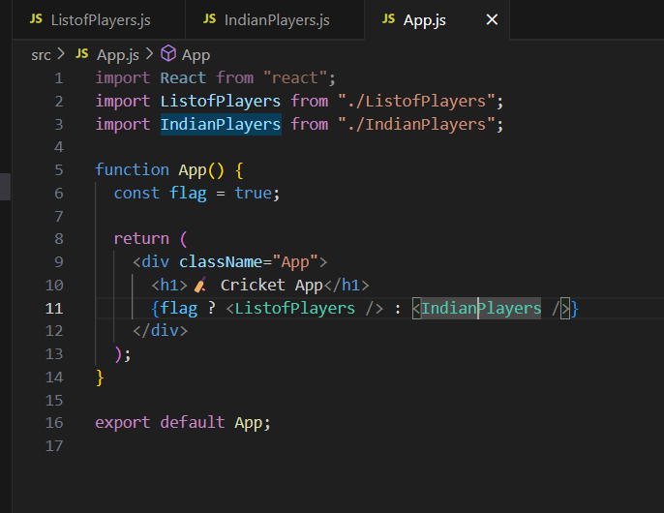

**STEP 7: Run Your App**

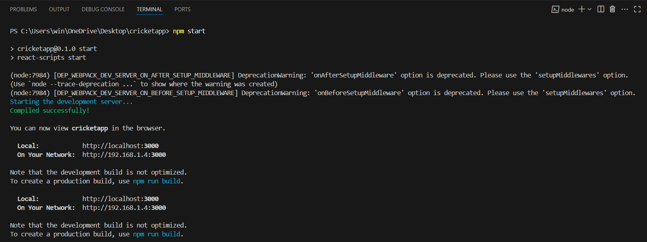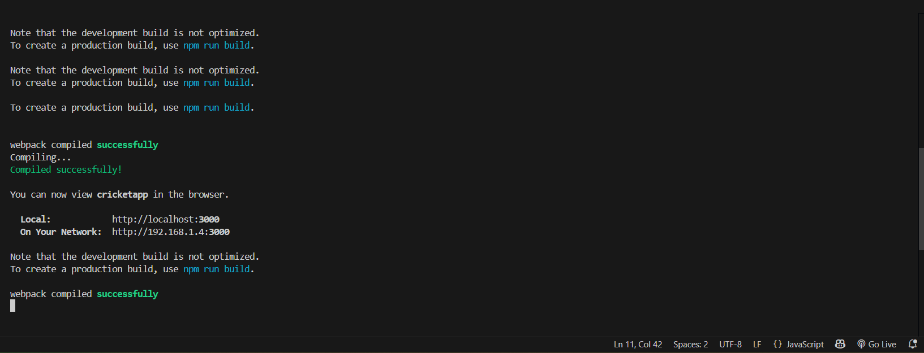

**Output:**

